|  |  |
| --- | --- |
| Name: Maezelle T. Secuya | Section : BSIT 3C |
| Assignment No: | Submission Date: April 6, 2024 |
| Assignment Title: Number Guessing Game | |

**Code :**

**HTML FILE**

<!DOCTYPE html>

<html lang="en">

<head>

<link rel="stylesheet" href="style.css">

<title>Number Guessing Game</title>

</head>

<body>

<div class="container">

<h3>Welcome to a number guessing game!</h3>

<p>Please enter a number between 1-10:</p>

<div class="col">

<input class="guessingBox" type="text">

<button class="btn">Enter</button>

</div>

</div>

<script src="main.js"></script>

</body>

</html>

**JS FILE**

document.addEventListener("DOMContentLoaded", function () {

const randomNumber = Math.floor(Math.random() * 10) + 1;

let attempts = 0;

const btn = document.querySelector('.btn');

const inputBox = document.querySelector('.guessingBox');

btn.addEventListener('click', checkGuess);

inputBox.addEventListener('keypress', function (e) {

if (e.key === 'Enter') {

checkGuess();

}

});

function checkGuess() {

const guess = parseInt(inputBox.value);

if (isNaN(guess) || guess < 1 || guess > 10) {

alert('Please enter a valid number between 1 and 10');

} else {

attempts++;

if (guess === randomNumber) {

alert(`Congratulations! You guessed the correct number in ${attempts} attempts!`);

} else if (guess > randomNumber) {

alert('Too high! Try again.');

} else {

alert('Too low! Try again.');

}

}

inputBox.value = '';

}

});

**CSS FILE**

*{

margin: 0;

}

body{

display: flex;

align-items: center;

flex-direction: column;

justify-content: center;

}

p , h3{

font-size: 25px;

font-family: 'Arial';

margin: 10px;

}

.container{

text-align: center;

}

.col{

display: flex;

flex-direction: column;

align-items: center;

}

.guessingBox{

text-align: center;

padding: 15px;

margin-top: 10px;

width: 150px;

height: 80px;

font-size: 50px;

}

button {

font-weight: 500;

padding: 10px 25px;

cursor: pointer;

border: none;

background-color: #690088;

color: #ffffff;

margin-top: 10px;

}

**SCREENSHOT**

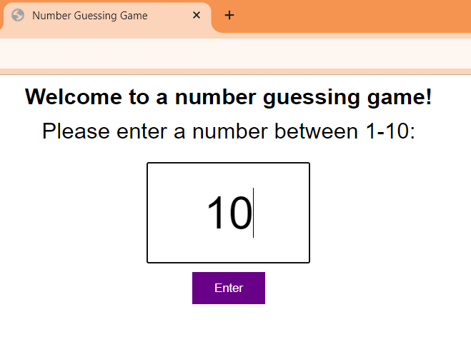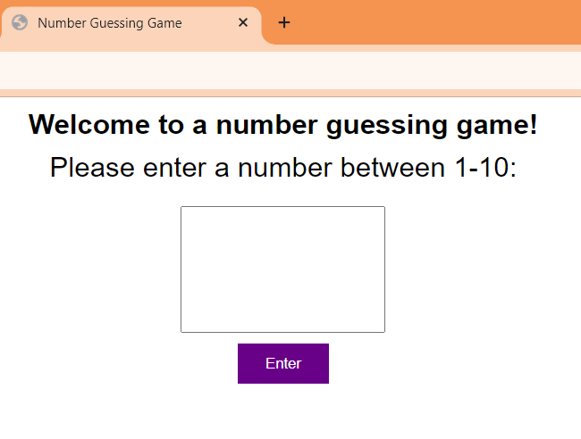

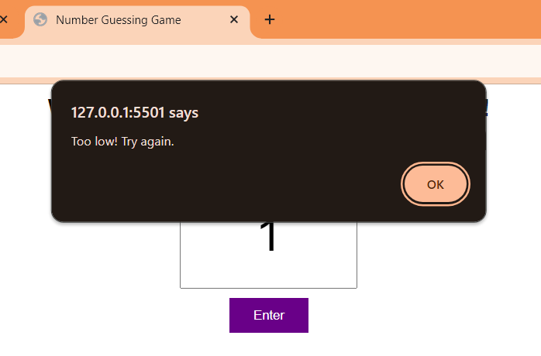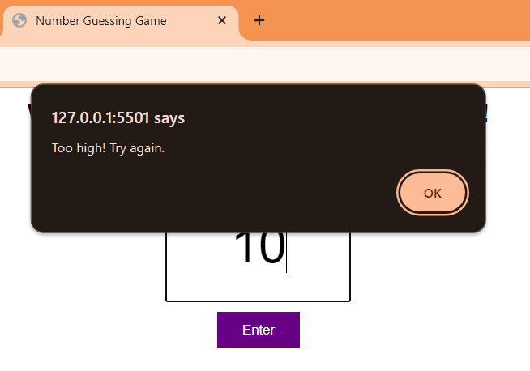

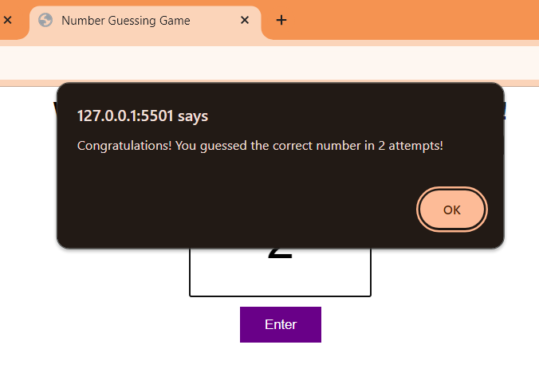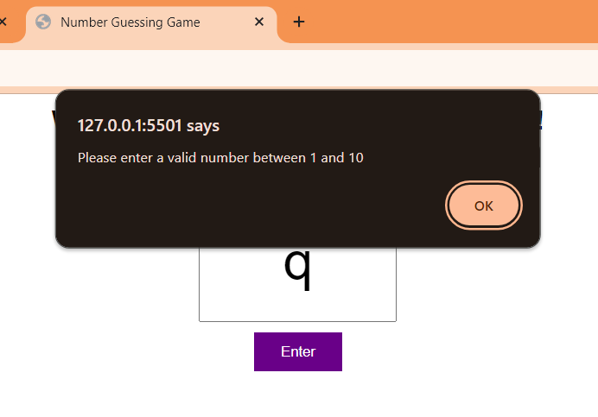

**Dictionary:**